**Looking for Global Warming in the UK**

CONN09

Academic: Richard Connor

**Sean McMahon**

Matriculation Number - 201312433

# Abstract

Table of Contents

Abstract 2

Introduction 6

1.1 Outcome 6

1.2 Report Structure 6

Background Study of Related Work 7

2.1 Justification for Related Work 7

2.2 Simple Graph Maker 7

2.2.1 Overview and Functionality 7

2.2.2 Strengths 8

2.2.3 Weaknesses 8

2.2.4 Similarities and Differences Compared to AnalysApp 9

2.3 Graph 10

2.3.1 Overview and Functionality 10

2.3.2 Strengths 11

2.3.3 Weaknesses 11

2.3.4 Similarities and Differences Compared to AnalysApp 11

2.4 Stocktradamus 13

2.4.1 Overview and Functionality 13

2.4.2 Strengths 14

2.4.3 Weaknesses 14

2.4.4 Similarities and Differences Compared to AnalysApp 14

2.5 Google Analytics 15

2.5.1 Overview and Functionality 15

2.5.2 Strengths 15

2.5.3 Weaknesses 16

2.5.4 Similarities and Differences Compared to AnalysApp 16

Problem Description and Specification 17

3.1 Problem Description 17

3.2 Requirements Analysis 17

3.3 Feature Detailing and Initial Specification and Requirements 18

3.4 Updated Final Specification and Requirements 18

3.5 Approach to Solving the Problem 18

3.6 Design Methodology 19

System Design 20

4.1 Why a Mobile Application? 20

4.2 Kivy 20

4.3 Python and KV Lang 21

4.4 Integrated Development Environment (IDE) 21

4.5 Buildozer 22

4.6 Python For Android 22

4.6 Kivy-iOS 23

4.7 Kivy App Lifecycle 23

4.7.1 build() 24

4.7.2 on_start() 24

4.7.3 on_pause() 24

4.7.4 on_resume() 24

4.7.5 on_stop() 24

4.8 UI Design 24

4.9 Good Practices 24

4.10 Application Permissions 24

4.11 Pandas 24

4.12 MatPlotLib 25

4.13 Design Patterns 25

4.14 How the System Design Relates to the Use Cases 25

Detailed Design and Implementation 26

Verification and Validation 27

Results and Evaluation 28

7.1 Overview 28

7.2 User Evaluation 28

7.2.1 Survey Evaluation 28

7.2.2 Client Evaluation (Richard? Section perhaps not required) 28

7.3 Project Evaluation 28

7.3.1 Bugs 28

7.3.2 Project Methodology Success 28

7.4 Final Results 28

Summary and Conclusions 29

8.1 Summary 29

8.2 Future Work 29

8.2.1 Bugs (If any are known to still exist) 29

8.2.2 Expand Data Coverage (Web API for American/worldwide historical data) 29

8.2.3 UI 29

8.3 Conclusion 29

Chapter 1

# Introduction

## Outcome

## 1.2 Report Structure

Chapter 2

# Background Study of Related Work

## 2.1 Justification for Related Work

Before work could commence on the application, a background study of several apps that provide similar functionality to “AnalysApp” had to be carried out. After searching the Google Play Store and iOS App Store, a number of applications were found to provide visualisation, forecasting and analytics functionality.

The applications listed below were used in the background study:

1. Simple Graph Maker (Android)
2. Graph (iOS)
3. Stocktradamus (iOS)
4. Google Analytics (iOS and Android)

## 2.2 Simple Graph Maker

### 2.2.1 Overview and Functionality

“Simple Graph Maker” is an application available to download from the Google Play Store. The app has over 100,000 downloads, and a rating of 3.4/5 from over 700 reviews (as of Dec 2017). The app appears in the top 3 results when searching with the term “Graph”. It is described as a “simple graphing tool” that allows users to “create a graph of a flat design easily”. It a wrapper for the Chart.js tool to provide Android compatibility with the framework. “Simple Graph Maker” is designed to allow users to create a number of different graphs with their own data, and to label the graphs and axes. There is also the ability to save graphs to file and then open them at a later date. It is free to download; however the application uses adverts as a means to make profit.

The application’s home screen contains five buttons, each with different functionality. The first three buttons are to create each graph type: pie chart, line chart and bar chart. The fourth button is to open graphs the user has previously saved and the final option is to view further information about the app itself.

Clicking on the “create a pie chart!” takes the user to a menu that allows them to input the graph title along with the data series’ names and accompanying values. Users can also set custom colours for each data series in the pie chart. Initially, the menu only shows inputs for three data series. In order to add extra series, users can select the “+ add” button at the bottom of the screen to keep adding data series as required.

Once the user is happy with their input data, clicking “CREATE THE CHART!” at the top-right of the menu takes the application to the display screen. This displays the pie chart with the labels of each section stored within them. There is also a legend in the bottom-left corner that shows the percentage of area that each section fills the chart. By clicking the “MENU” button at the top-right of the display, three options appear for the graph: the user can either save the graph within the app, save it to their phone’s saved images or share the image through another app such as Gmail or Dropbox.

The bar and line chart menus both have the same menu for setting graph and data series labels as that of the pie chart option, though this screen doesn’t have inputs for values for these chart types. There is an extra menu between the labelling screen and display screen, and this is where users input the y values/coordinates for each x value. Selecting the “CREATE THE CHART!” button brings the user to the graph display screen again like with the pie chart menus.

Selecting the “Open Saved Graphs” menu brings up a display showing the visualisations in descending order from the oldest saved graph. Finally, the “About” screen shows information about the developer and their other apps, along with the licenses of the open source frameworks used.

### 2.2.2 Strengths

* The UI for “Simple Graph Maker” is simple and easy to understand and grasp. The button’s use rounded rectangles, which gives a softer look to the application by not having any sharp corners in the design.
* User’s can go from the home screen to viewing a graph within three screens. This allows users to see instant results, rather than be lost in endless amounts of menus and inputs.
* The application is robust and coped well with various inputs, and no crashes occurred when creating multiple graphs for each graph type. It is visible from this that the developer has extensively tested the application, and that the third party Javascript libraries have also been tested and validated to the same extent.

### 2.2.3 Weaknesses

* Elements of the UI are too simple and grammar on the buttons and labels is poor also: there is little use of capital letters throughout the app, preventing the application from having a professional feel. This amateur look could put discourage users from downloading the application in favour of one that looks like it has been produced by a full development team.
* The app displays the adverts continuously, even when entering values to input boxes. This can means that almost half of the screen can be taken away from the main screens of the application, and can hinder navigation. As understandable as it is for the need for adverts in mobile applications to generate profit, the placement of some of them can irritate users after a period of time.

### 2.2.4 Similarities and Differences Compared to AnalysApp

“Simple Graph Maker” shares some common functionality with the AnalysApp application. Both aim to make the creation of graphs as quick and easy as possible for the user, and strive to keep the UI simple so that people of all age ranges can use them. The application also allows users to save graphs, which aligns with one of the advanced features of AnalysApp.

The applications differ in the chart types they offer: Simple Graph Maker allows users to produce three types of graph whereas AnalysApp will only produce line graphs. Simple graph maker also allows users to label graphs and axes with custom text, which was not considered for the development of this application, however this feature could be included in the advanced additions. Simple Graph Maker gives multiple options for the saving/sharing of graphs outwith the app itself, but this is beyond the scope of the ten-week development period for AnalysApp however could be implemented if the project was continued after the assessment period.

Figure 2

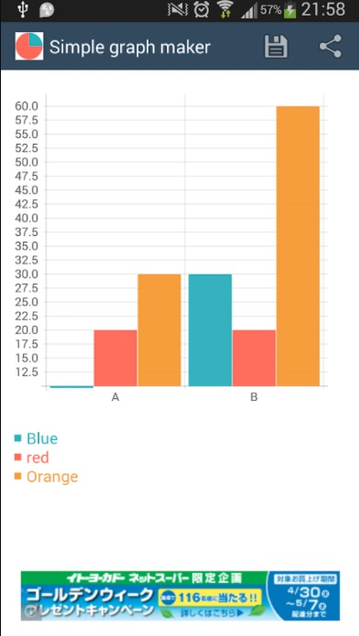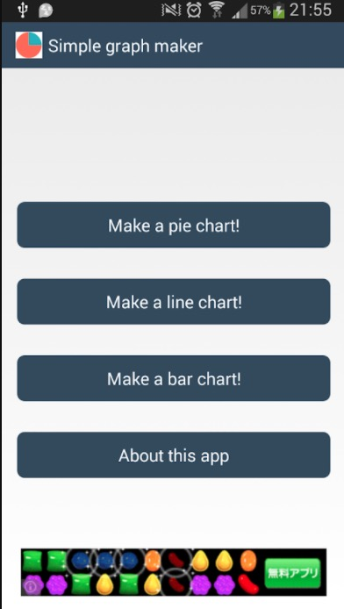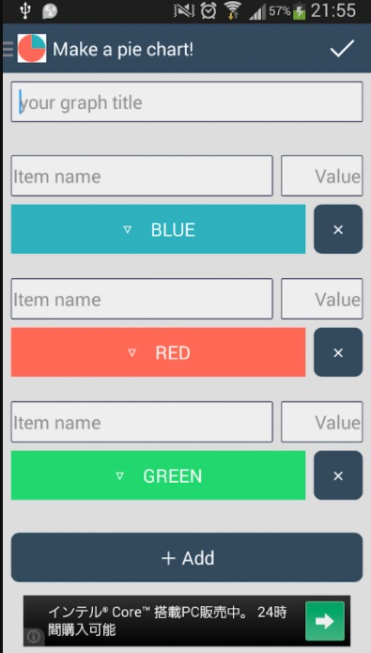

Figure 3

Figure 1

## 2.3 Graph

### 2.3.1 Overview and Functionality

“Graph” is an app available for free on the iOS App Store. It has been available to download for six years and has an average rating of 1.5/5. As Apple does not include download figures in the App Store, it is unknown how many devices the application has been installed on. The application’s description on the App Store explains, “Graph is straightforward” and allows users to create 1D, 2D and 3D graphs from numbers and functions.

After launching, the home screen for the application presents the user with a scrolling list of the various graph types that can be created, along with the extra options that can be unlocked for an in-app purchase of £5.99: for example, error bar graphs and graphs for monitoring health and weight. App settings can also be configured at the bottom of this scrolling menu.

Once the type of graph has been selected, the application transitions to the graph settings screen. This screen presents the multiple options tabs for the graph to be created, and these options are split into three headings: “Textual”, “Graphical” and “General” options.

The first option, “Table Editor”, appears under the “Textual” heading and when selected brings up an input screen, which contains a simple spreadsheet for the values to be entered into. Using the top and bottom slider buttons scroll the spreadsheet horizontally and vertically, respectively. Labels for each ‘x’ value can also be inserted and the options buttons at the top-right of the screen allows the user to import/export data or clear the spreadsheet.

The second option of the graph settings, which appears under the “Graphical” heading, displays the graph and its labels. The Edit button allows the user to select different views of the graph, and from here they can send an email to the developers of the application to suggest new view options for the graphs.

The “General” heading contains the final three options from the graph settings menu. The “Graph Preferences” option brings up the input screen for setting the labels of the graph and its axes, and also for specifying the minimum and maximum values for the domain and range of the graph. The second option under the General heading lets the user switch between the data being presented in a bar, column or pie chart and whether to animate the state of the graph. Finally, the “Manual” option brings up a guide for the user on how to input data and configure the graph.

These options are the same for all the different graph type on the home screen of the Graph app. The differences occur in the data input screen, as some graphs require functions rather than numbers as input.

### 2.3.2 Strengths

* The application offers a comprehensive range of graphs to produce, and the use of spreadsheets to input the data series allows users to easily enter large amounts of data quickly, especially with the import data functionality.
* Having one spreadsheet for each type of graph, i.e. one for 1-Dimensional graphs, one for 2-Dimensional graphs etc. makes it very simple for users to quickly alter the graph that is used to display the values. For example, a user need only enter values once in the 1-Dimensional graphs screen and can then tab between bar, column and pie chart without having to enter any more values.

### 2.3.3 Weaknesses

* There is very little assistance or explanation within the app on how to format the values/functions users input into the application. If a value is entered in an invalid format, the cell will remain empty and no error or warning message displays to explain why the input was incorrect.
* There are many options and graph types for the user to select and this is very confusing when using the application for the first few times. The UI and ads displayed seem very homemade and prevent the application looking professionally made.
* The lack of explanation or help buttons in the app makes it very difficult for those with little understanding of graph functions and 3D models to pick up this app and use it immediately. As one review on the App Store said, “It is clear this app is only good if you are an expert with this type of thing”.
* Although the health and weight monitoring features are useful and bring value to the app, the in-app £5.99 purchase to unlock these contents seems very expensive and off-putting to most users.

### 2.3.4 Similarities and Differences Compared to AnalysApp

This application, like Simple Graph Maker, aims to allow users to produce graphs using their own values and data. The app takes the data and puts it into graph form and, like the initial project specification for AnalysApp, users are unable to customise the colours etc. of any data series in the graphs produced.

Like Simple Graph Maker, the Graph produces different graph types than AnalysApp would offer in the original project specification. An advanced feature of the application, therefore, could be to allow users to produce various graph types for data that could incorporate this feature.

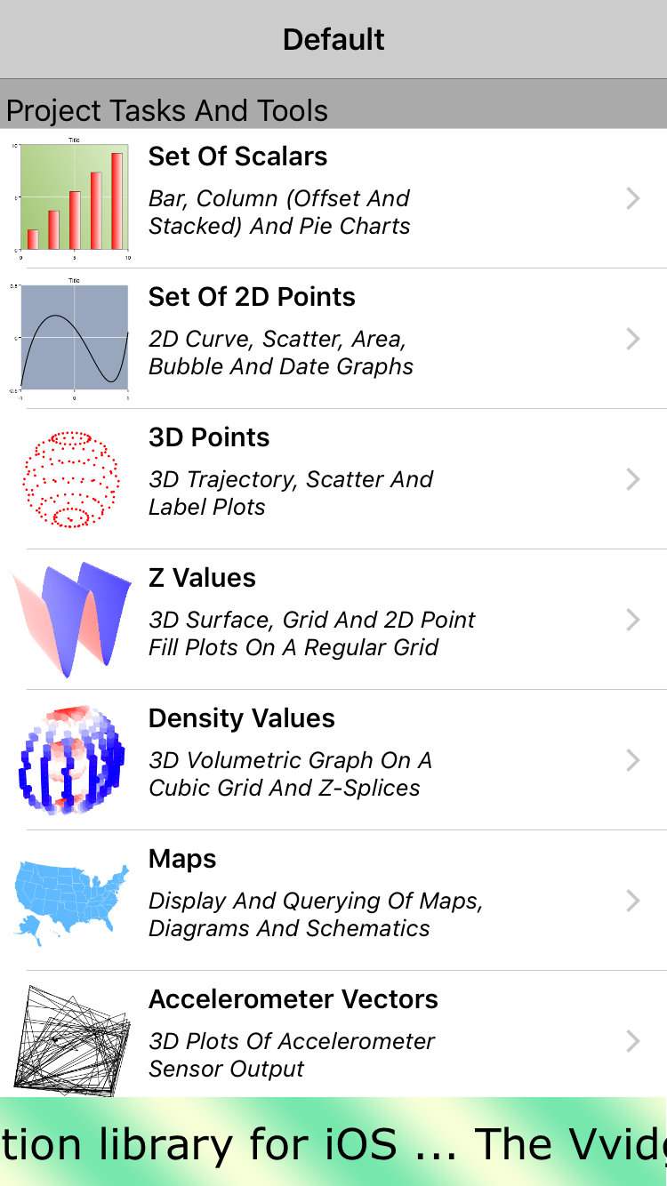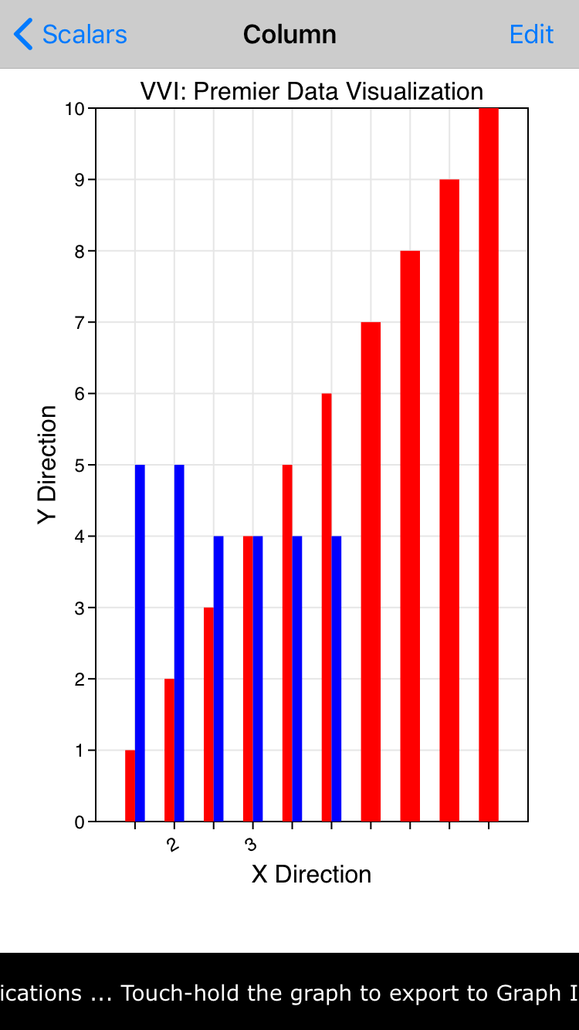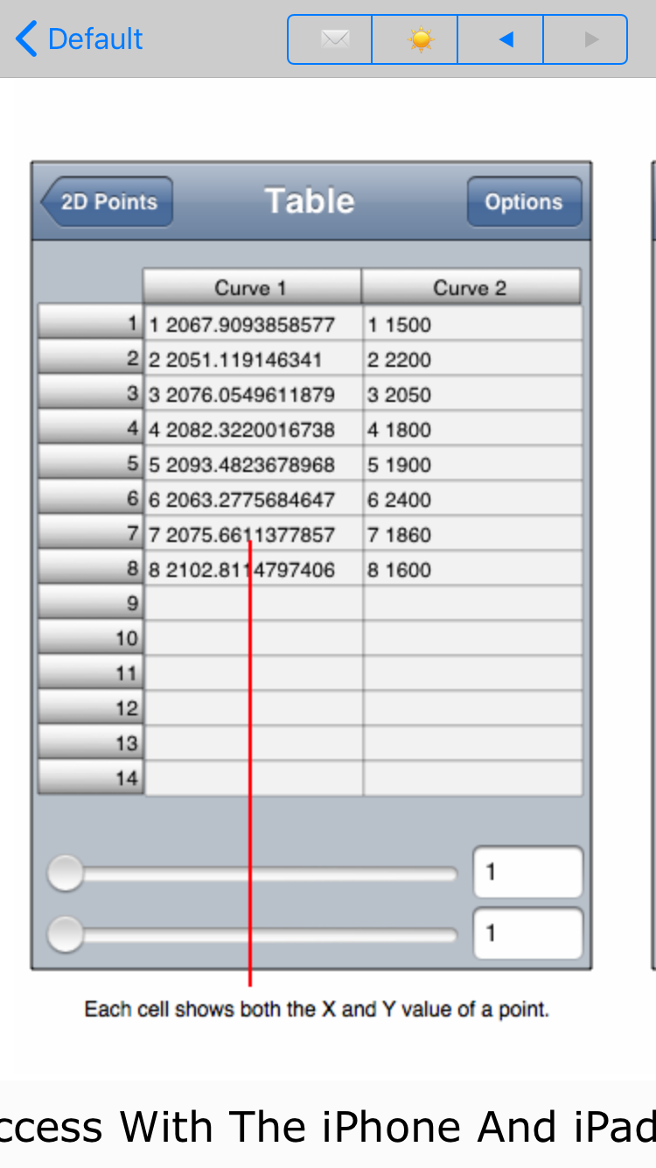

Figure 7

Figure 9

Figure 8

## 2.4 Stocktradamus

### 2.4.1 Overview and Functionality

Stocktradamus is an app available to download on the iOS App Store for a purchase of £1.99. Again, due to Apple not releasing download figures it is unknown how many users have installed the app on their devices. There are no reviews for this application.

The applications purpose is to predict the future value of stock that have at least five years worth of previous stock value data. The user enters a stock ticker name, and selects a time frame for the prediction, and the app will create an Auto Regressive Integrated Moving Averages (ARIMA) model of the existing data and use this to predict the future values. The application’s description on the App Store heavily emphasises that it should be used purely for educational purposes and not as an accurate tool for making investment decisions in stocks.

The home screen for the application is the main input screen and has a simple black background, with labels and inputs using white and cyan coloured text. The first input asks for a stock ticker symbol and the second is a Scrollview for selecting the prediction window. The options in this Scrollview range are 1-9 months or a year. There are three buttons beneath the input areas: two for restoring in-app purchase and view subscriptions terms, and one to start the ARIMA prediction. If the user has entered an invalid stock ticker or a ticker for a stock with less than five years then an error message is displayed to the user.

Clicking the “Done” button with valid inputs will display a temporary loading screen while the model calculates the future values. This screen shows the date of the prediction, the stock ticker to predict and the prediction window selected on the previous screen. Once complete, the app transitions to the results screen. This screen also has the stock ticker and prediction window, and displays the result in the form “Up/Down by x%”. If the model predicts the stock will be higher in value then the background of this label is green, or red for a lower prediction.

If the users wishes to view advanced details on the ARIMA model prediction, they can select the “View forecast details” button at the bottom of the results screen. However, to view these details, an in-app purchase of £1.99 must be made, and this must be paid every time the user wishes to view these advanced figures for the prediction model. Alternatively, users can sign up to a monthly £7.49 subscription that allows them to view unlimited advanced figures for results models.

Once on the advanced figures screen, the user can view the parameters used for the ARIMA model, test statistics for stationarity and how well the model fits the actual values. As well as these test statistics, there is a graph showing the price chart for the predicted stock. This graph displays the historical data for the stock and the ARIMA model’s historical and predicted values. Users have the option to save these forecast details either to the device or via email. If emailing the results, the application uses the iOS Mail app to send a screenshot of the results screen to the given email address.

### 2.4.2 Strengths

* The app is extremely simple to use. The user only has to input two values into the application for it to create a complete prediction model, and can go from the home screen to viewing a stock value prediction in seconds.
* The advanced results give users a greater insight into how the model was created and it is useful to be able to save these results or forward to someone else for viewing.

### 2.4.3 Weaknesses

* The main weakness of this app is its’ pricing. £1.99 is expensive for an app of this size and more than double the common price of £0.79 for iOS apps. Charging users per individual viewing of advanced results is also very off-putting and expensive. If the cost for this feature was a one off fee, then it would perhaps encourage more users make the purchase.
* Once a user is on the basic results screen, they have no way to return to the home screen and create a new prediction. The only way to do this is to close the app completely and restart it.

### 2.4.4 Similarities and Differences Compared to AnalysApp

Stocktradamus is similar to AnalysApp for using an ARIMA model to make its predictions. It also tests a number of different parameter combinations for the ARIMA to see which gives the best accuracy to use as the final model.

However, both applications differ in how they retrieve their data. Stocktradamus sources the stock data via a web server whereas AnalysApp stores the data locally in text files. Storing the data on a server reduces the size of the application by a small fraction, but also means that users cannot predict data when they have no Internet access.

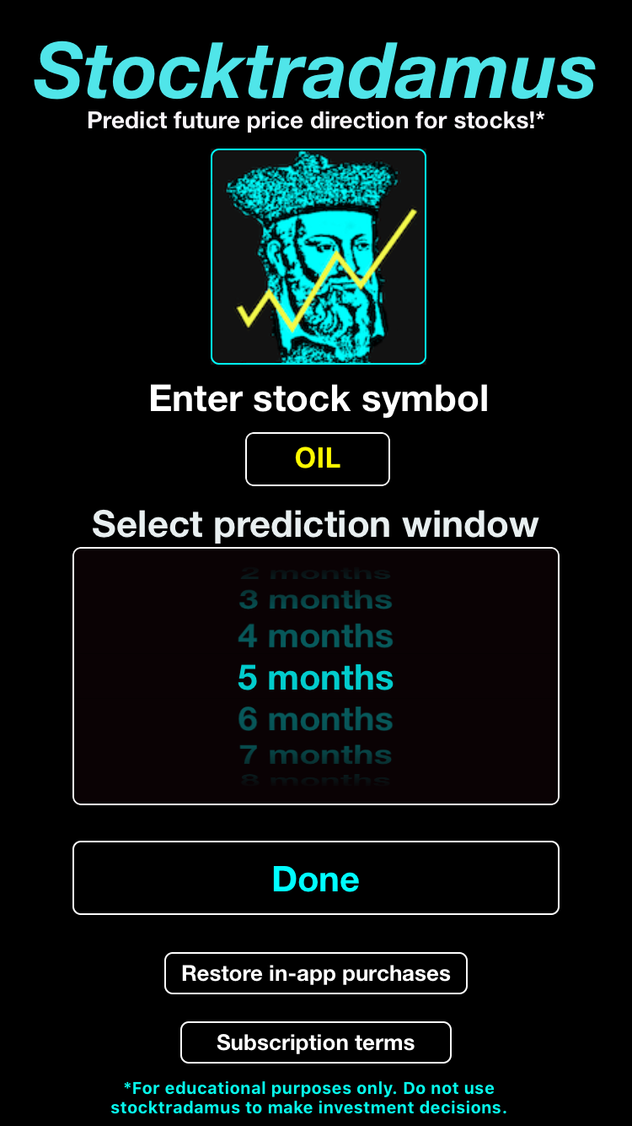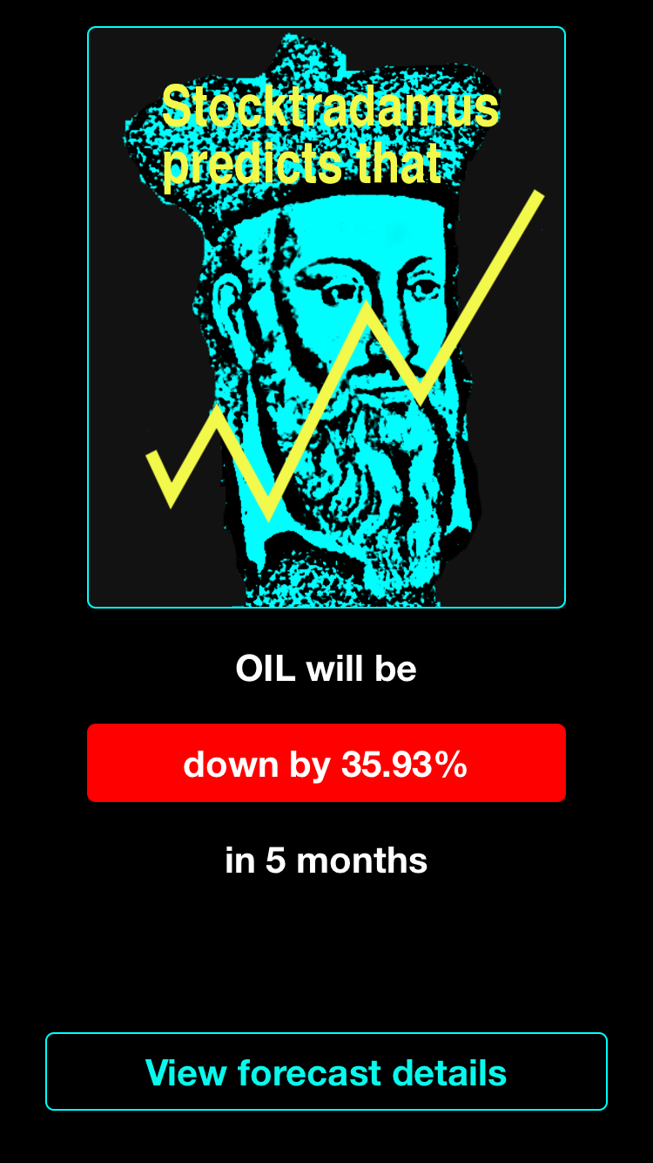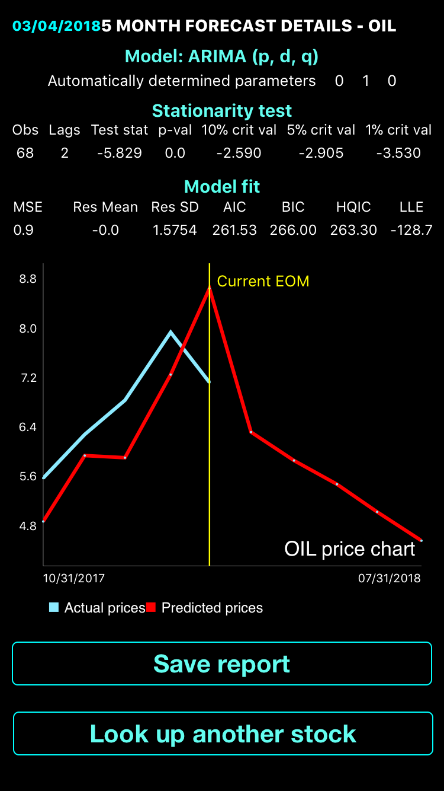

Figure 7

Figure 8

Figure 9

## 2.5 Google Analytics

### 2.5.1 Overview and Functionality

Google Analytics is an app available to download for free from both the App Store and the Google Play Store. Users can also access the Google Analytics tool via its website on their browser (<http://www.google.com/analytics>). The tool aims to give users greater insight and statistics on their website in order to analyse information such as number of users in a given time period or which pages in the site are the most viewed. It has over one million downloads for Android alone, with a rating of 4.5/5. On iOS, the application has an even better rating of 4.8/5 but the 276 reviews from iOS users is miniscule compared to over 60,000 reviews on the Play Store.

In order to use the tool, users need to create an account and install the tracking tool into their website. This is a block of simple Javascript code that is added to the html code of every page in the website. Once this has been added, the analytics information should begin to appear in the app as users visit the website.

When the user logs into the application, the home screen is displayed and users are presented with a weekly view of their analytics. This screen shows a summary of each of the categories that users can pick from the side menu. These graph displays are grouped into categories such as audience overview to see figures for new or returning visitors to the website, behaviour overview to view statistics on how long visitors stay on the website and time stats to view users by the time of day they viewed it. These sections also offer comparisons against the previous time period in order for users to analyse whether their site is performing better or worse than before. Users who have Ecommerce sites can also view these results within the app and examine revenue over time, the percentage of sales by device type, popular products and many more statistics.

The app has functionality for users to create reports based on the analytics data f or use in other analysis methods or perhaps present to other colleagues. The ability to add other users and set their access rights means that a full team can use the tool and team members can have individual roles or abilities assigned to them.

The application also allows users to ask questions by speaking into the devices microphone and the analytics tool will use Google’s speech to text to generate a query on the data. Users can then save these results to view at a later date.

### 2.5.2 Strengths

* It is clear the tool has been created by a team of professional developers, due to the slick, easy-to-use user interface and breadth of analysis on offer to users. The tool is obviously well trusted also due to the number of users who have integrated it with their confidential site data.
* The app allows users to set goals for their sites, for example to increase site traffic by 5%, and then to track these goals in real-time. This gives the ability to track goal progress at any given moment and make decisions on the spot, rather than wait until the goal time has passed before viewing the results.
* Users can switch seamlessly between viewing the mobile and web app, meaning that the analytics data can be viewed at anytime, in any location and on any device.

### 2.5.3 Weaknesses

* It is difficult to find weaknesses in this application, though one could be the sheer volume of data presented to the user. For new users, this could mean a steep learning curve before finding out how to get the most from the tool. Google has extensive documentation and tutorials, though, that could help users to quickly understand how to use the tool.

### 2.5.4 Similarities and Differences Compared to AnalysApp

Google Analytics is similar to AnalysApp by aiming to provide users with a greater insight of their respective datasets. Analytics also allows users to refine the dataset used in the analysis, i.e. by device or site page. This is similar to AnalysApp, which would allow to users refine the dataset by station, data type or date range.

It is obvious that Analytics offers much more functionality than AnalysApp could, but this is expected due to the sheer size and expertise of the developer. The app offers many more graph types than AnalysApp and has a full documentation site for help and Q+A sections. Although this is not possible for AnalysApp, a small help article can be added within the app itself to assist users with the application’s functions.

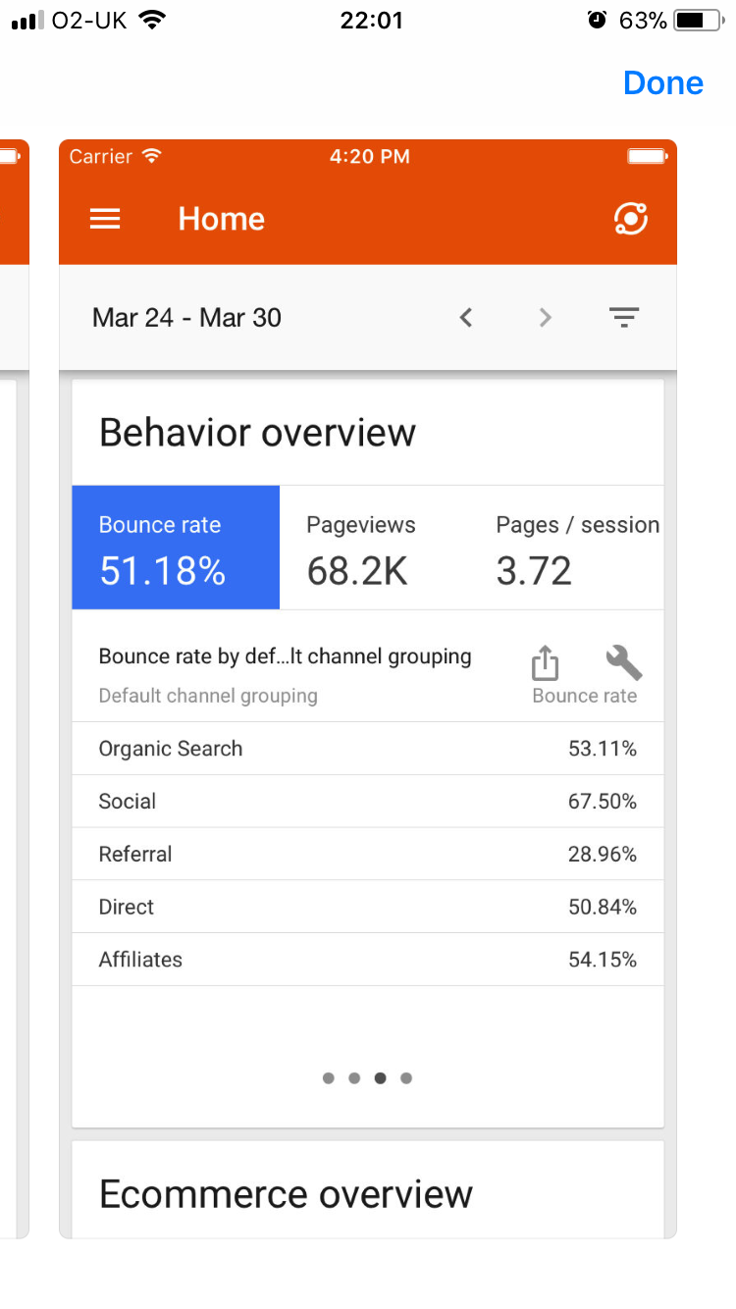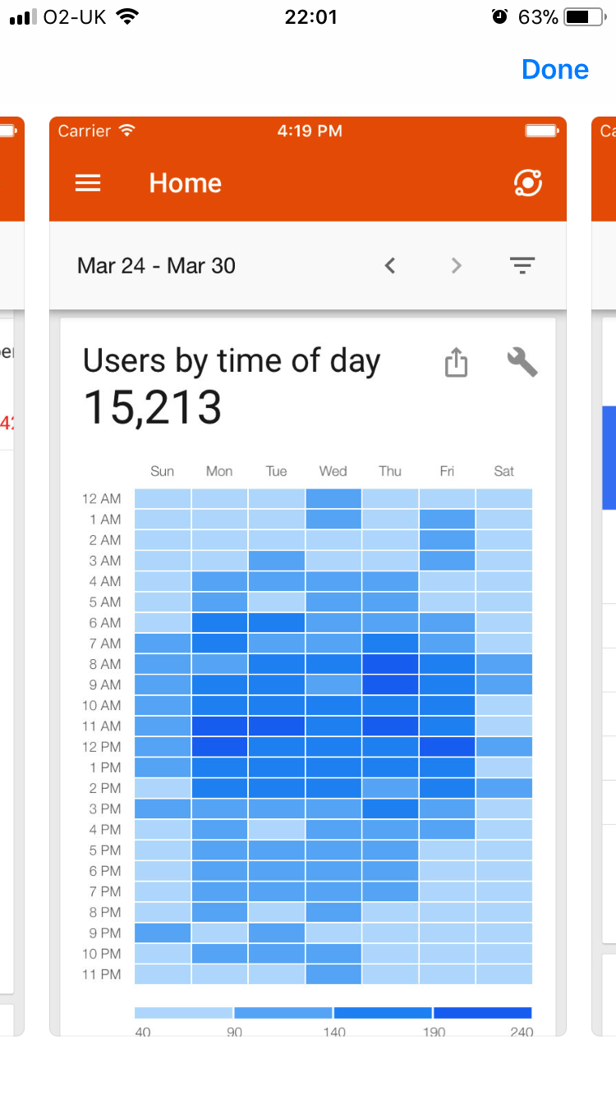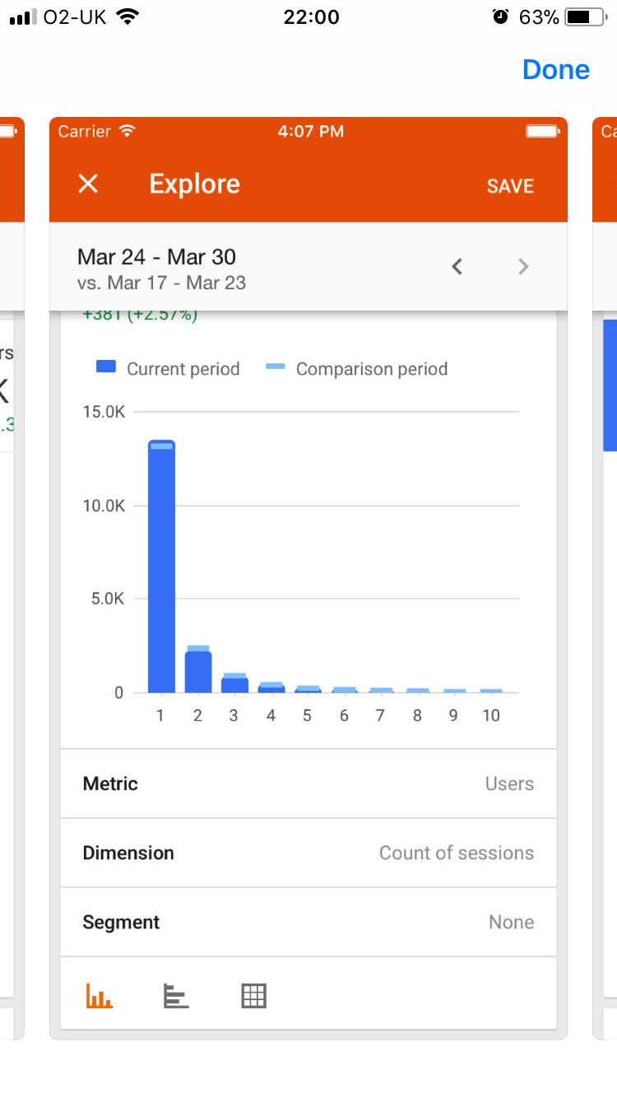

Figure 12

Figure 11

Figure 10

Chapter 3

# Problem Description and Specification

## 3.1 Problem Description

Initially, the project specification was simply to produce a piece of software that could do some interesting form of analysis on the historical weather data available from the Met Office. In order to be able to target more users with the final product, the decision was taken very early on to produce a mobile application. This could then be targeted at students in school/university or members of the general public who have an interest in weather or global warming, to gain a greater understanding of the UK’s weather systems.

“AnalysApp: UK Weather” aims to allow users to view, forecast and analyse historical weather data from thirty seven of the Met Office’s weather stations on a mobile or tablet device. The app tries to provide users with a greater insight into the UK’s weather and climate over the last hundred years and will allow users to look for signs of global warming within the country. To do this, the app has been split into three clear features:

1. Data Visualisation
2. Data Forecasting
3. Data Analytics

Each of these sections had to be researched, implemented and tested separately whilst still using the same data model. Precaution was taken to ensure the finished features brought value to the app and that they were simple and easy to use by the survey groups.

## 3.2 Requirements Analysis

Upon speaking with the project supervisor, further detail was received on the specification for the app. These were the three features bullet pointed above, and it was also said that the results of these features could be displayed through well presented graphs that explain to the user the steps that were taken in any calculations. With these details noted, the features needed to be fleshed out in terms of what they would do.

## 3.3 Feature Detailing and Initial Specification and Requirements

**Primary Features**

* **Data Visualisation**
  + View maximum/minimum/mean temperature, rainfall, sun hours and air frost days.
  + View data by station, country or Britain as a whole
* **Data Forecasting**
  + Predict future data
  + Predict past data
  + Predict future and past data in the same graph
* **Data Analysis**
  + Look for trends in the data for a particular station/data type
  + Any changes in mean value of data types
  + Any changes in standard deviation of data types

These primary features were deemed vital to include in an app that would work and perform well on a mobile device. For this reason, these were the first to be implemented in the app. This was decided on the belief that the ten-week development window would be sufficient to have all of these features in the application.

**Extra Features**

* Save last x amount of graphs created to quickly view again without recalculation
* Colour blind UI option
* View advanced details of forecasting model
* Speech to text input
* Ability to view weather graphs (maximum & minimum temperature plotted against rainfall)
* View multiple data series in a single graph

These extra features are not vital to the finished application, however if time remained at the end of the development process then some of these features would be implemented in order to give a more polished final product.

## 3.4 Updated Final Specification and Requirements

<To be written at once development complete>

## 3.5 Approach to Solving the Problem

In order for the application to be available to as many users as possible, it was decided that it should be cross-platform. For this reason, the Python framework Kivy was used for development, as the developer had experience programming in Python, and the Kivy framework had support for compiling to Android .apk files and iOS Xcode projects. As the developer had not used the Kivy framework before, some initial reading of the Kivy documentation and best practice was carried out to avoid teething problems during initial development.

Each feature was implemented separately, in the order bulleted under Primary Features in section 3.3. The project was developed with the intention of being a fully working mobile application, but not quite ready for deployment to the App Store or Google Play Store due to the developer’s inexperience in creating well-designed, fluid user interfaces (UI). Such prototype-like UIs could hinder the app’s success on the marketplace were it to be launched at the end of the ten-week period. For this reason, a simple prototype UI was used in development with the intention of creating a more appealing one if time permitted.

Research was also carried out to find and understand how to use any Python data modelling and visualisation packages, as these would be vital to the production of the application. The developer attended a Python data science event hosted by JP Morgan and Cambridge Spark at the firm’s Glasgow office, and this contributed greatly towards learning how to manipulate, work on, and visualise the weather data.

Throughout development unit testing was carried out using the Python Unittest module to reduce errors and bugs at run time. As each feature was implemented, it was extensively tested by the user and also by a small group of volunteers who completed surveys after testing each component.

Each feature was developed on top of the existing codebase, as opposed to developing them all in separate applications and combining them at the end of the project. This would also ensure all features worked with each other and the data model as any changes were made.

## 3.6 Design Methodology

It was decided very early on in the project that an Agile approach would be used in the development of the application. Fortnightly sprints would be allocated to each of the three main features, with the remaining two sprints being used for adding advancements and improvements to the existing features. These remain sprints could also be allocated to adding in some of the components listed in the extra features if all primary ones were completed. Each sprint was linked to Trello, a project management application, to allow easy monitoring of sprint progress and to easily copy any incomplete tasks over into the sprints allocated for advancements and improvements. Using this approach would prevent delaying the development of other sprints.

Chapter 4

# System Design

## 4.1 Why a Mobile Application?

The first decision to be made with the project was whether to create a mobile, web or desktop based application. With current statistics predicting there being 2.5 billion smartphone users in 2018, (<https://www.statista.com/statistics/330695/number-of-smartphone-users-worldwide/>) and these users having round the day access to their devices, a pure desktop application was ruled out. This left the choice between developing a web application or a mobile one, but due to the developer’s limited experience in web development, the preferred and final choice was to develop a mobile application.

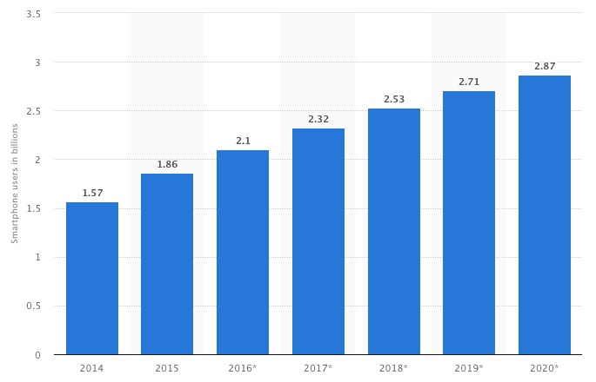

Figure 13 – Predicted Smartphone users from 2014-2020 in Billions

## 4.2 Kivy

The two development platforms considered for mobile were Android and iOS, as they accounted for 99.9% of mobile devices in the first quarter of 2017.

(<https://www.idc.com/promo/smartphone-market-share/os>)

Though Android held 85% of the market, one of the developer’s aims for the project was to target as many users as possible. For this reason, it was decided that the application should be cross platform and from a single code base, so this ruled out using the native Java and Swift languages.

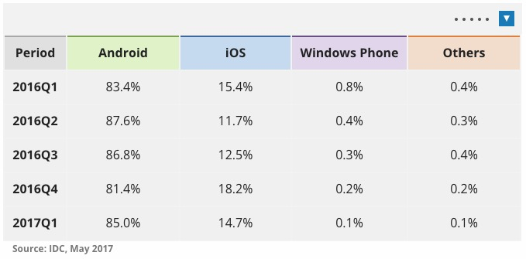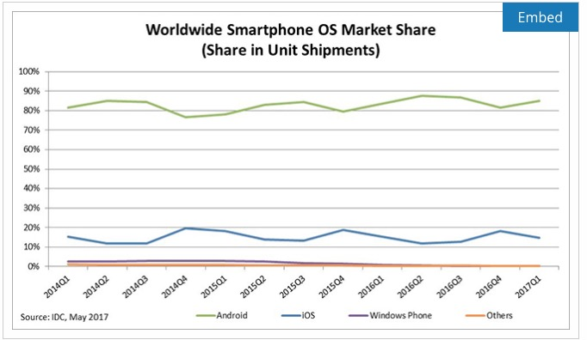

Figure 14 and 15 – Mobile Device Type By Share of Market

The next stage of the process was to research the possible cross-platform development tools that could be used for the implementation of the project. A number of tools were found, but the majority of these, such as PhoneGap and Appcelerator, use a Javascript/HTML codebase before compile to the desired platform. Due to the lack of development experience in these languages as mentioned in section 4.1, these tools were not considered.

The next possible development framework considered was the Kivy open source Python library. Kivy is a free to use library that runs on Linux, Windows, OS X, Android, iOS and Raspberry Pi. (https://kivy.org/#home) The framework provides widgets that support multiple touch, mouse and keyboard events and a graphics library using OpenGL ES 2. It also has its own intermediary language, known as KV lang, for designing custom User Interface widgets. This KV lang helps developers to follow a Model-View-Controller design as the KV lang files can be kept separate from the model. As the framework is mostly Python and not just a wrapper around a library written in another language, it makes it very easy for users to extend and customise widgets exactly how they want.

The framework also has many support channels for developers with any questions or issues with it. These include StackOverflow, Google Groups and many more. These channels allow developers to quickly get help from existing users as well as the Kivy core developers who can give expert advice and help.

Once the user has written their Kivy application, there are various tools for compiling the code for different platforms. These tools are discussed in later subsections.

## 4.3 Python and KV Lang

The design of a Kivy application is generally split into two sections. These are the

Functionality/model of the application and the User Interface and are written in Python and KV lang, respectively. The User Interface can be written in Python code in the same classes and the application’s model classes but separating this into KV lang files makes the code base easier to read and maintain. The decision to use a Python based framework was due to the developer having gained a year’s experience using the language while taking part in a fifteen month industrial placement in between their third and fourth year of studies. The developer felt more comfortable programming in a language they had previous experience with and only having to learn the about the modules/packages used, rather than having to learn both in the ten week development period. Also, as Python is a high-level language, the developer would not have to write any platform-specific code.

## 4.4 Integrated Development Environment (IDE)

Though Kivy and Python applications can be written through a command line terminal, the majority of these are written using an Integrated Development Environment (IDE). This is because using an IDE is less time consuming and includes error checking and built in debugging features. Some of the popular IDE’s used for Python development are PyCharm, IDLE and Spyder, however there are also plugins for use with Eclipse and Visual Studio. Following recommendations on the Kivy support channels, the PyDev plugin for Eclipse was the chosen IDE for this project. The benefits of this included not having to learn the layout of a new IDE as the developer had previously used Eclipse for development.

## 4.5 Buildozer

In order for the finished application to run on a mobile device, the code must be compiled to the respective file type. For Android this is an .apk file and for iOS the code must be converted to an Xcode project. There are instructions in the Kivy documentation on how to install tools and do this manually through the command line, but there are tools that greatly simplify this for developers. One of these tools is Buildozer, a Python module available through the Pip installer.

Buildozer works by creating a single application specifications file, named “buildozer.spec”. In this file, users specify the application title, icon, module dependencies etc. and then running the Buildozer command from the terminal will run the appropriate tool based on the platform to compile to. Using Buildozer makes compilation to each desired platform much simpler for the developer as they do not have to understand how each individual build tool works. Users simply have to enter the required values into the buildozer.spec file and leave Buildozer to fill the remaining options with default values before running the necessary commands.

## 4.6 Python For Android

Python For Android (P4A) is an open source tool originally developed for converting Kivy apps into standalone Android apks but now supports porting many Python packages to the file type. The tool runs from the command line terminal and includes a number of features:

* Create a debug version of the application for testing on a personal device.
* Create a signed application for uploading to the Google Play Store.
* Deploy the compiled apk to a connected physical device or emulator.
* Print the device or emulator’s log output to the terminal to aid in debugging the compiled application.

The tool takes the developers code and a list of dependencies to be included in the compiled apk. The script will then create a virtual environment for the project and install the required Pip modules to it. For Pip modules that are purely written in Python, the porting process is simple, but for modules that include low-level C code the task is more complex. These interoperable modules require a ‘Recipe’ – a collection of scripts that take care of compiling any compiled components of the Pip module. These must also be compiled for the correct architecture. A handful of Pip modules have already had recipes created for them by the Kivy community, though many modules that involve a large amount of compiled code still await recipes to be written.

## 4.6 Kivy-iOS

Kivy for iOS works the same way as Python for Android, but has some more dependencies in order to work. It can only run on the OS X operating system and requires Xcode and Cython to be installed on the host machine, and it includes the same features as Python for Android. However, instead of producing a file ready for installation on a device or simulator, the tool takes the Kivy project code and produces an Xcode project ready to be opened by the application. The app can then be run signed through the Xcode application.

## 4.7 Kivy App Lifecycle

Kivy applications have a number of different states during their lifecycle. Users opening, closing and returning to the application causes this state to change. As these state changes occur, various callback methods are invoked in order for the application to react accordingly to the user’s actions. The developer can use these callback methods to perform any necessary loading/saving of files or any other actions that may have to be carried out. There are five callback methods in the Kivy application lifecycle:

* build()
* on_start()
* on_pause()
* on_resume()
* on_stop()

### 4.7.1 build()

The build callback method initialises the application and is only called once in the entire lifecycle of the program. This is used for retrieving the widget tree and root for the application. AnalysApp will define all user interface widgets in the KV lang files and these will be loaded into the widget tree as the build method is called.

### 4.7.2 on_start()

The on_start method is fired after the build callback but before the application has started running. This method can be used to perform any initial actions the application requires such as checking the platform it is running on in order to make any necessary configurations.

### 4.7.3 on_pause()

Android and iOS devices mainly call the on_pause callback method. It is not possible to control when this method is called, as it only occurs when the user closes the application without fully stopping it. This method should return true if the application can go into Pause mode, and false otherwise. If false is returned, then the application will be stopped. This method is also used for resizing.

### 4.7.4 on_resume()

Figure 16 – Kivy Application Lifecycle

The on_resume method is called when the application is about to exit Pause mode. This should be used to render any UI elements or OpenGL graphics that may have been freed by the application/operating system during Pause mode.

### 4.7.5 on_stop()

The on_stop callback is called when the application is about to be closed. This should be used to save any files and safely stop any resources that the application was using before they are freed.

## 4.8 UI Design

The end product for AnalysApp at the completion of the ten-week development period was to be a full feature demo application. This was so that the majority of development could be focused on feature functionality rather than on aiming to create the slickest user interface possible. Even so, it was still important to the developer to create a clear, concise user interface that would be simple for users to understand and make use of.

The plan for the development of the application’s interface was to create a prototype interface for use in initial development and testing. Then, once the main functionality was completed for the app, a cleaner, more professional looking interface would be developed. This second interface would bring the application closer to be ready for deployment to the App Store or Google Play store, and research on its design would be carried out by comparing existing web forms online for good and bad aspects.

## 4.9 Good Practices

While developing the AnalysApp application, a focus was placed on following and implementing the many practices and conventions of Python and Kivy developers. These conventions are recommended in order to provide cleaner, more readable code that is easier to maintain and to improve the overall quality of the code. The conventions followed throughout the development process are as follows:

### 4.9.1 Python Enhancement Proposals (PEP)

Python Enhancement Proposals are collection of documents that propose major new features, collect the Python community’s opinion on an issue and detail the design decisions that have been made for the Python language. There are three types of PEP documents:

1. Standard Track PEP – describes a new Python feature or implementation
2. Informational PEP – details Python design issues or suggests general guidelines to the development community. However it does not propose new features.
3. Process PEP – these are similar to Standard Track PEPs but differ in that they can apply to other topics than just the Python language. Usually these PEP documents are enforced and users do not have the choice to ignore them unlike with other PEP document types.

### 4.9.2 Kivy API

The Kivy API documents all widgets and components that are available to use in the framework. Within each entry are details on how to initialise the widget, both in Python code and in KV language, as well as the various callback events that methods can be bound to. Along with these API details, there are example code snippets that show the best way to use the widget.

### 4.9.3 String Constants

In order to improve maintainability of the code, the application will utilise a string constants file. Using this constant file will greatly reduce the number of string literals used throughout the code, and mean that common strings between files only require updating in a single location if they need to be changed. It will also ensure consistency in common labelling across User Interface widgets.

## 

## 4.10 Application Permissions

As the application does not require access to any device hardware like a camera, microphone or web browser, no app permissions will be required from the user after installation in order for the full functionality to be available.

## 4.11 Pandas

Before any of the main features of the application can be implemented, the data from each of the thirty-seven text files from the Met Office must be loaded in. While carrying out the initial research for the development of the application, the obvious choice for the in-memory storage of the data was Pandas.

### 4.11.1 What is Pandas?

Pandas is a Python library for data manipulation and analysis. As explained on the Pandas website:

***‘****Pandas is a Python package providing fast, flexible, and expressive data structures designed to make working with “relational” or “labelled” data both easy and intuitive. It aims to be the fundamental high-level building block for doing practical, real world data analysis in Python. ‘*

There are two main data structures in Pandas: Series and Dataframes. Series are one-dimensional structures and Dataframes are two-dimensional. Dataframes are a collection of Series.

### 4.11.2 Reasons for using Pandas

Pandas can read data in from a text file and automatically create the appropriate data structure with column names and row indexes. The data structures can also be grouped by particular columns values and have operations performed on these grouped values such as max, min, mean or standard deviation. Pandas also handles missing data and provide many approaches to filling these rows with values. As well as this, there are simple methods for performing queries on the dataframe or series. All of these features make the package an ideal choice for use in the AnalysApp application.

## 4.12 MatPlotLib

The main feature of the application is the ability to produce graphs to present the data, forecasts and analysis results to the user. It was important to find a package that could provide this functionality early on in the research phase of the project as this tool would be used throughout the application’s codebase.

### 4.12.1 what is Matplotlib

Matplotlib is a Python two-dimensional plotting library for producing a great variety of graphs. The package describes itself as trying to “make easy things easy and hard things possible. You can generate plots, histograms, power spectra, bar charts, error charts, scatterplots, etc., with just a few lines of code”. The package allows users full customisation of the graphs that they produce, from setting axis labels and series titles to setting the location that the graph legend will be placed.

### 4.12.2 Reasons for using Matplotlib

Matplotlib provides the ability to save graphs that are produced. As well as this, the package is well integrated with Pandas, which makes this an obvious choice for use in the application. As it is so popular within the Python community, there is a vast amount of documentation on how to use the package also, which would help greatly throughout the development cycle.

## 4.13 StatsModels ARIMA

StatsModels is a Python package for creating statistical models of datasets and statistical data exploration. It includes a number of methods for representing statistical data, but the one that suits the needs of the AnalysApp project is the ARIMA model. Before looking at the ARIMA model, it helps to understand the general approach to time series data forecasting.

### 4.13.1 Forecasting Time Series Data

In order to forecast time series data, a number of techniques must be applied. The first thing that must be done is to ensure that the data is stationary. Stationary data means that things like mean and variance in the data remain constant over time. For example, given a dataset of sales of sunglasses, it helps to first view the data and plot the series in a graph.



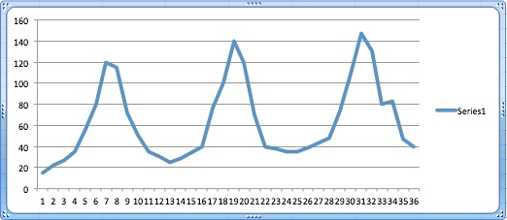

We can then plot the rolling mean and the rolling standard deviation alongside the original data to check for stationarity. Rolling means that for point *x* in the data, we perform the given action on this point and the previous *y* values. For example, the rolling mean at index 3 if *y=2* is calculated as:

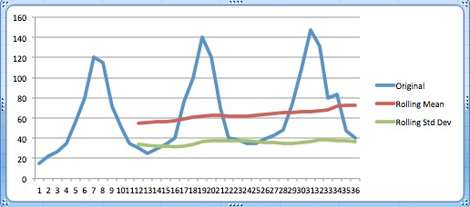

As can be seen from the graph, there is both seasonality and a positive trend in the data. The rolling standard deviation increase is minimal so this does not impact much, but the rolling mean gradient does. Before any forecasting can be performed, these aspects must be removed from the data set in order to make it stationary. It is important to note also that both the rolling mean and rolling standard deviation do not have values for the first eleven points in the data set. This is because we set a lag of twelve so we do not start get values until we reach index twelve.

In order to remove trend from a data series, we can first apply transformation. Transformation is the technique of applying a function that penalises higher values. There are many functions that can do this for us, such as log, square root, cube root etc. For this example we will take the log of each value. Once we have the log of the series, which we will call ts_log, we can apply differencing. Differencing is when take the previous value in the series away from the current value in it. We apply differencing to ts_log to give us ts_log_diff. We can then plot the rolling mean of ts_log_diff to give us our new data series:

Now 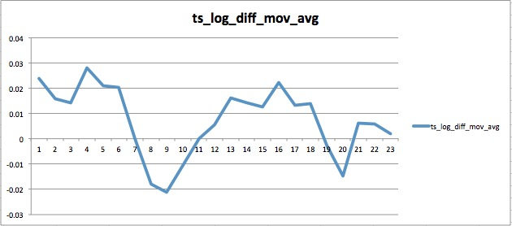that we have greatly reduced the seasonality and trend, we can model ts_log_diff_mov_avg using ARIMA.

### 4.13.2 What is ARIMA?

AutoRegressive Integrated Moving Average (ARIMA) models, in theory, are the most general type of model for forecasting a time series of data. The model requires three parameters as well as the data series to be modelled. These parameters are named p, d, and q, and they correspond to the AR, I and MA components of the ARIMA model, respectively. These parameters are integers and tell the ARIMA function how to manipulate the data before modelling it.

Using an ARIMA model of (1, 0, 0) simply gives us an autoregressive model (AR). This AR model with parameter 1 can be written as:

Where:

So if our model estimated *A*(1) to be .45, then our current value would be 45% of the value at the last step plus our error term. If we used an ARIMA model with parameters (2, 0, 0) then the values would be calculated as:

The model’s values would be calculated in the same manner, except we would use the past two values in the time series rather than just one.

If we use a model of (0, 0, 1) gives us a moving average (MA) model. MA models can look similar to AR models but they are quite different. AR models take account for values at previous steps in the time series, however MA models only look at the random error of previous time steps. Our MA model of parameter one would be:

Where:

This equation tells us that any value in *X(t)* is only related to the random error of the current step and the previous step.

When we combine these AR and MA models we get an ARMA model, and buy adding our third parameter, *d*, we get an ARIMA model. The *d* parameter tells us how much differencing we want to apply to our time series. For example, if this was given an Integration value of 1, then each value is difference using the method:

Where:

So using an ARIMA(2, 1, 2) model means we have a second order autoregressive model with a second order moving average element that has been differenced twice to give stationarity.

In order to know what parameters to use in an ARIMA model, numerical and graphical evaluation of the time series must be performed. As the application cannot have some look at the data and know with expertise the parameters to use, it will try a variety of parameter combinations to model the existing data. It will then use the model that is most accurate to the actual data to create the forecast.

## 4.14 Design Patterns

## 4.14.1 Observer Design Pattern

The Observer design pattern aims to create a one-to-many dependency between observers and an observable object. In this design, whenever the observable objects changes state, all of its observers are notified so that they can perform any necessary actions with this new state.

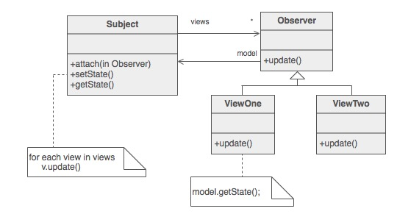The Kivy framework has a great focus on using the Observer design pattern. The Property object that exists in the framework allows the developer to bind a callback method that is triggered whenever the objects value changes. These will be used throughout the user interface implementation, so that in the KV lang files we can set label’s text values and dropdown list options to a Property variable, and then the controller only has to work with the Property variable rather than continuously access the view. This will help to decouple the code and to improve the readability of the controller classes.

### 4.14.2 Strategy Design Pattern

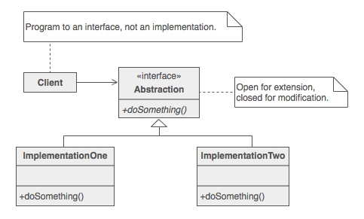The Strategy design pattern tries to define a group of algorithms and to then make it possible for these to be swapped out in place of each other. This means that the algorithm can change independently from the classes that use it. The AnalysApp application will use the Strategy design pattern as data is retrieved from the Data Access Object (DAO). When data is grouped by a particular time period, users will have a choice of operation to perform on these groups such as max, min or mean. The application will pass the operation/strategy to use when grouping the data and then have the finished data series returned to the object that called the method.

### 4.14.3 Singleton Design Pattern

The Singleton design pattern aims to ensure that a class can only have one instance of itself, and have a global point to access this single instance. Within Python, there are two ways to do this:

1. Create the global instance of a class
2. Rather than create a class, develop a module of methods that can be imported as required

Both of these methods will be used in the application, with method one being used for the DAO object. Kivy allows the global variables to be assigned to the root app widget, and then be accessed from chid widgets. The second method will be used for plotting the graphs that the application requires. The object performing the user’s requested action will import the plotting methods from the application’s graph plotting module rather than create an instance of a plotter object.

Chapter 5

# Detailed Design and Implementation

## 5.1 Application Data

### 5.1.1 Preparing the Data

Before any widgets are added to the root widget of the application, the Data Access Object is created. As the DAO is instantiated, a dictionary is created to map each station name to its respective Dataframe. The data used for each station is taken from the Met Office historical data web page, and each station on this page has a separate text file containing its historical weather data. These text files look like the following:

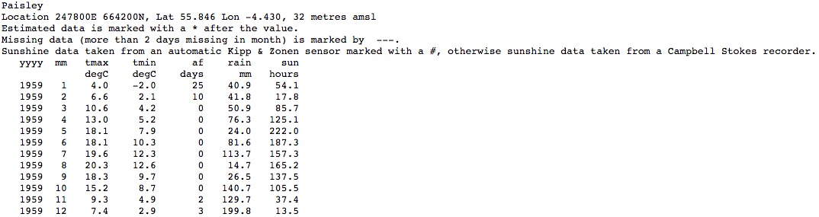

In order for Pandas to parse this text file in a Dataframe, the initial description lines must be removed so that column headers can be identified. The following code block then creates and formats the Dataframe:

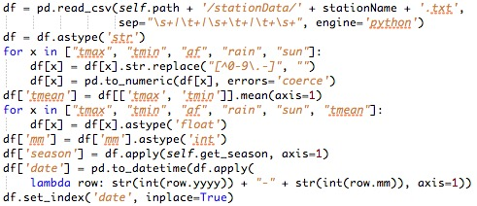

This code block is called for every station, and initially converts all data to be of type String. Some of the data contained in the Met Office text files contains special characters as can be seen here:

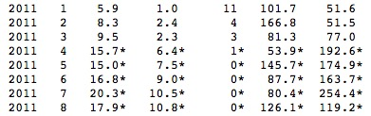

These special characters are used for a number or reasons, but they are mainly to show if a value is only a prediction, if the recording is from a different location within the station’s region, or if the recording equipment is different from the equipment that was originally used. In order to make the understanding of the data in the application easier for users, the decision was made that these special characters should be removed, rather than to alert the user every time a graph was created using this data. As well as this special data, there are rows in the text files that contain missing data and are identified “---“ like so:

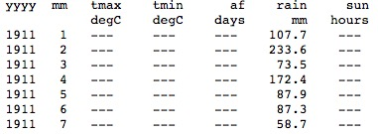This missing data can be accounted for in the pd.to_numeric() method call. By using the parameter “errors=’coerce’”, any data that cannot be converted to an integer or float, like “---“, is simply replaced with Numpy’s “Not a Number” (NaN) value. This NaN value will make future processes easier, as the Pandas and Matplotlib modules both have Numpy support and can handle NaN values.

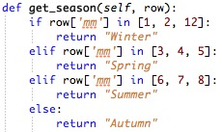

The penultimate step this code block performs is to add two extra columns to the Dataframe – ‘season’ and ‘date’. Combining the year and month value in every row creates the date column. The season column is created using the get_season() method. Finally, we set the newly created date column as the index of the Dataframe in order to make slicing and querying the Dataframe easier when retrieving data.

### 5.1.2 Retrieving Data

Whenever data is retrieved from the DAO, a number of values must be specified:

* Region – The station or country’s data to return.
* Datatype – The values to return, from the range {“Max Temp”, “Mean Temp”, “Min Temp”, “Rainfall”, “Air Frost Days”, “Sun Hours”}
* Start – The start of the results date range.
* End – The end of the results date range.
* Step – How to group the data, either by month, season, year, decade, by a particular month or season annually, or by a custom month range annually.
* Operation – a function to apply to this grouped data, either max(), min(), mean() or standard deviation.
* Month_range – this value is only required if the Step variable is set to group the data by a custom month range. This variable is a list of months to use when group the data annually.

If the data to be returned is for a single station, then the appropriate Dataframe is returned from the station dictionary. However, if a country or the United Kingdom is specified, then all stations with that region are concatenated with one another. The concatenated table is then sorted by index. This sorted Dataframe can then be sliced using:

This line of code slices the Dataframe similar to the way that Python lists can be sliced. The difference is that the *.loc* method includes the end index in the returned table, whereas sliced Python lists return all items up to, but not including, the end index. Once the data has been down to the specified time range, it can then be grouped by the selected time step. The DAO class has a number of methods to do this depending on the chosen time step. The majority of these methods are similar to the following:

This line first fills any rows of data containing the NaN value with the value of the last row containing an integer value. The table then groups data by a specified column name – ‘yyyy’ for year, ‘mm’ for month and ‘season’ for season. The grouped data is then turned into a list. The operation specified by the user, eg max(), can then be applied to each row in the series before returning the final data set.

## 5.2 Plotting Graphs

The AnalysApp application requires graphs to be produced in every feature. Sometimes these features require a single graph to be created and saved, whereas at other times two graphs need to be created and saved in a single image.

### 5.2.1 Plotting a Single Graph

The code used to plot data in a graph is fairly simple. Using the Matplotlib module, a Figure object is created and its size specified. Then for each data series, the values are plotted and the series’ title is added to the legend. Before setting the ticks, labels displayed to mark values on a axis, along the x-axis, a check is performed on the length of the longest data series to be plotted:

This section of code is used to reduce the number of ticks that are displayed on a saved graph, as tick labels can overlap if too many are displayed. This code simply halves to size of the list on each iteration by retaining every second element in the list and discarding the rest. Once this list’s length is ten or less we can assign it as the graph’s x-axis ticks. The graph is then saved to file and the Matplotlib figure closed.

### 5.2.2 Plotting Two Graphs

The code for plotting two graphs and saving them in a single image is very similar to that for plotting a single graph. The only difference is that instead of creating two Figure objects, we create one for the first graph and then call the add_subplot() method on the original Figure object in order to plot our second graph. The data can be plotted and label assigned in the same manner before saving the image.

## 5.3 User Interface

### 5.3.1 Wireframe Draw Ups

Before any User Interface elements were implemented, some wireframe mock-ups were created. These prototypes were made so that the developer had an early idea as to how the interface would be laid out, and to save time when it came to implementation. The Balsamiq web tool was used to create the mock-ups.

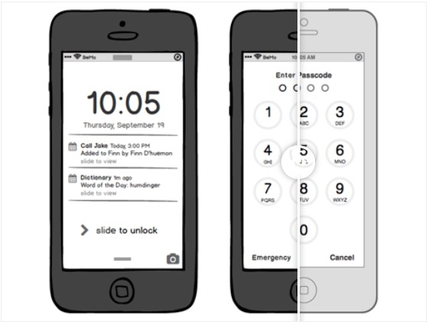Balsamiq is “a rapid wireframing tool that helps you work faster & smarter. It reproduces the experience of sketching on a whiteboard, but using a computer”. The tool provides a number of device layouts to create the wireframes for, such as tablets, smartphones and desktop screens. The web tool also features a great variety of UI widgets that can be dragged and dropped into place easily. The widgets can be expanded, reduced and their colours altered. There is also the capability to add other users to the wireframes and allocate these users different access rights to the storyboard.

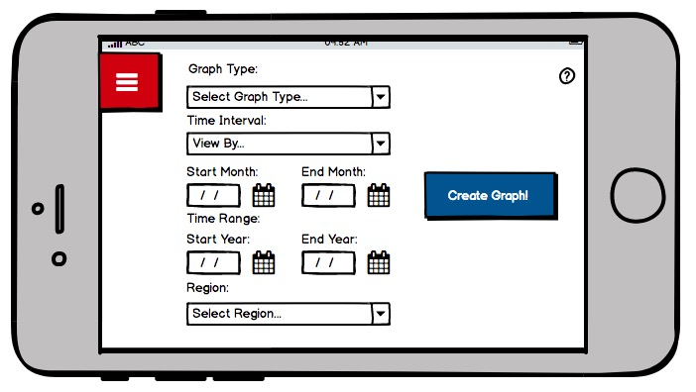

### 5.3.2 Implementation of Interface Using KV Lang

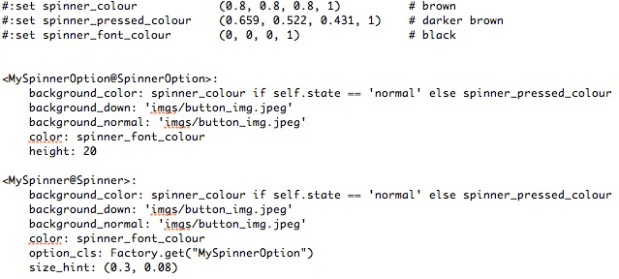Once these wireframes were created, the next stage was to implement these using the KV Lang. The majority of the User Interface was created using the standard Kivy widgets, such as the Labels, Buttons, and NavigationDrawer for the side menu. In order to create the dropdown menus, the standard Spinner class was subclassed in order to customise it slightly as so:

The code block above first defines some variables to use in the KV lang file. These three variables are used to set the colours required for the dropdown menus throughout the application and only have to be defined in a single KV file, rather than in every file used in the application.

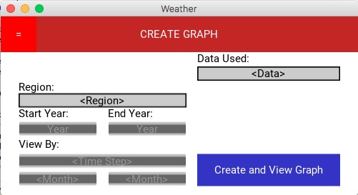Secondly, the code creates subclasses of the Spinner and SpinnerOption widget classes. This is done in pure KV lang rather than combining Python also, and is done simply by defining the subclass name and then using ‘@’ followed by the parent class. The common attributes for these components are then defined, and unique parameters are added later in the file as the components are used. The finished initial UI looked like the following:

As can be seen, the “Start Year”, “End Year” and “View By” dropdown menus are disabled by default. This is because every station’s data starts and ends on different dates, and even each data type for a station has different dates again. Locking these inputs initially forces the user to provide a station and a data type, and once these have been selected the view’s Controller will call the DAO to retrieve the available years to select and update the dropdown menus with this list.

### 5.3.3 Refactoring of User Interface

It is easy to see that the initial interface created for the AnalysApp application is rather basic. This interface was chosen initially as it would be quick to implement, leaving more time to produce the back end of each feature of the application. As time was available at the end of the development cycle, this basic/prototype interface could be reworked and improved.

This new interface used many of the same components as the basic interface, but rearranged them and altered their sizing. The main difference that can be seen between the two interfaces is the use of a background image and the removal of the header bar. The header bar was removed as it took up a fifth of the interfaces total area, and it was felt that this space could be better used. The background image concept was used as an attempt to try and remove as much dullness as possible from what could be interpreted as a boring input form. This new interface was implemented throughout the application, with the background image changing to a different location within the United Kingdom for each feature.

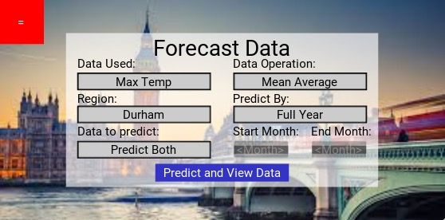

## 5.4 Data Visualisation

As the Data Visualisation feature was the simplest of the application’s three main components, this was the section first implemented out of them. The functionality of this code is fair straightforward and can be described in the following steps:

1. User inputs selection criteria
2. Controller passes criteria to DAO and receives data series
3. Data series passed to plotting method and graph saved as image
4. Interface transitions to graph display screen.

The data is then displayed to the user on the following screen seen below, and they can then select the back button to return and select new criteria to visualise.

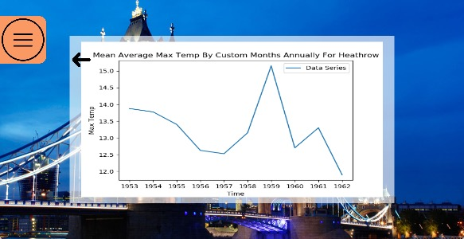

## 5.5 Data Forecasting

### 5.5.1 Estimating Best ARIMA Parameters

The second of the main features to be implemented was the application’s data forecasting section. This section used a similar interface to that of the visualisation section, apart from replacing the inputs of “Start Year” and “End Year” with the choice of prediction type. These prediction options are “Future Values”, “Past Values” or “Both Values”. Once the user has selected the criteria to forecast/predict, the controller calls the application’s Predictor object to create the forecast.

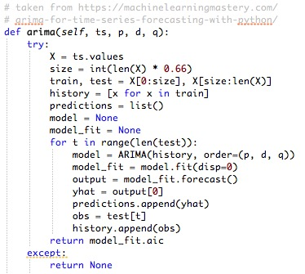For the given prediction type, the Predictor begins by estimating the best parameters to use for the ARIMA model. These are estimated by using the following best-fit code:

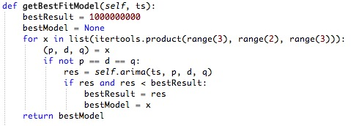

This code can be summarised in the following pseudocode:

1. For each combination of the lists [0,1,2], [0,1] and [0,1,2]:
2. Create an ARIMA with the given parameter combination
3. If the AIC of the model is less than the lowest current model, retain the parameters of the current model
4. Return the best parameters for the given dataset

Here, AIC stands for the Akaike Information Criteria. The AIC of a model refers to how accurate the ARIMA models values compare to the actual values of the data series. The general approach when comparing these AIC values is that a lower value represents a more accurate ARIMA model.

### 5.5.2 Producing the ARIMA Forecast

Once the best parameters for use in the ARIMA model have been selected, it is time to predict the future values using the following code:

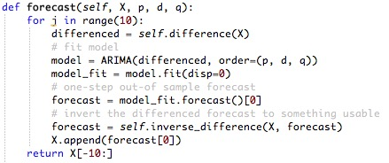

This code uses a loop that iterates ten times to perform the following pseudocode:

1. Difference the time series to improve the ARIMA prediction, as described in section 4.13.1
2. Create an ARIMA model of the differenced data series
3. Use the ARIMA model’s forecast() method to predict the next value in the series
4. Invert the differencing in order to get a value in the same region as our original data.
5. Add this new value to our existing data in order to retrain the ARIMA data model.

The predicted data is then returned to the controller, which in turn uses the Plotter methods to save the forecasts to a graph and display this to the user.

## 5.6 Data Analysing

### 5.6.1 How to Analyse the Data Set

The last of the application’s features to be implemented was the Data Analysing component. Again, this feature used a similar layout to the previous components, except for only having two dropdown menus for input: “Region” and “Data Type”. Once the application’s user chooses these parameters, the controller passes over to the Analyser object.

The Analyser object performs two operations in its analysis of the data:

1. Return the month and operation with the *greatest* and *lowest* increase in values by year or by decade.
2. Look for a mean trend and standard deviation trend for the region and data type.

### 5.6.2 Finding the Greatest and Lowest Trend Increases

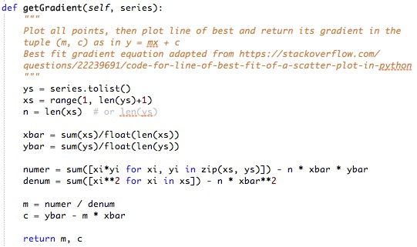This section of the analysing process works by using a nested for loop to get every combination of month and data operation. For each combination, the data set is grouped by decade and by year. Each of these grouped sets then has a line of best fit calculated using the getGradient() method:

For any given data series, the line of best fit is calculated as:

1. Set *ys* to the values of the series
2. Set *xs* to each element index for the series
3. Set *n* to the length of the series
4. Set *xbar* to the average of all the index values in *xs*
5. Set *ybar* to the average of all the values in *ys*
6. Sum the product of each value in *ys* and corresponding index in *xs* and subtract the product of *n, xbar* and *ybar* before storing the result in *numer*
7. Sum the squares of all indexes in *xs* and subtract the product of *xbar* squared and *n* before storing the result in *denum*

The variables *m* and *c* that are instantiated at the end of this function are constants that can then be used in the equation of a straight line of best fit:

Where:

This gradient, *m*, gives us the trend for the data series. A positive value in *m* tells us that the values are increasing with time, and a negative value means the values have a decreasing trend. This equation can also be used to calculate the y value of any x-axis coordinate and vice versa. As a result, this method could have been in the data forecasting feature of the application in place of the ARIMA model.

The initial nested loops for each possible month and data operation combination then retain the gradient with the largest and smallest value of *m* and returns these to the controller to display in the interface.

### 5.6.2 Identifying a Trend in Mean and Standard Deviation

The final step in the analysis of the given data series is to look at the mean and standard deviation values for each year. In the context of rainfall, for example, the mean will give us the average rainfall for a given year and the standard deviation will tell us how much the rainfall values varied from month to month within the year. If the data shows an increase in mean or variance, then this could be attributed to being a sign of global warming within the United Kingdom.

The Analyser object groups the mean and standard deviation values by year before calculating the gradient. It then returns the results to the controller, which then plots these results in a graph for the user to view. An extra screen is included after the graph display interface that contains a text label explaining the analysis results in further detail.

## 5.7 Compilation of AnalysApp

## 

Chapter 6

# Verification and Validation

Chapter 7

# Results and Evaluation

## 7.1 Overview

## 7.2 User Evaluation

### 7.2.1 Survey Evaluation

### 7.2.2 Client Evaluation (Richard? Section perhaps not required)

## 7.3 Project Evaluation

### 7.3.1 Bugs

### 7.3.2 Project Methodology Success

## 7.4 Final Results

Chapter 8

# Summary and Conclusions

## 8.1 Summary

## 8.2 Future Work

### 8.2.1 Bugs (If any are known to still exist)

### 8.2.2 Expand Data Coverage (Web API for American/worldwide historical data)

### 8.2.3 UI

## 8.3 Conclusion

Appendix

References

Trello

Kivy

Met Office data

Stackoverflow posts

Github issue posts google group posts